Bidwill Events

Term 1 Week 2: Feb 1 to 5, 2020

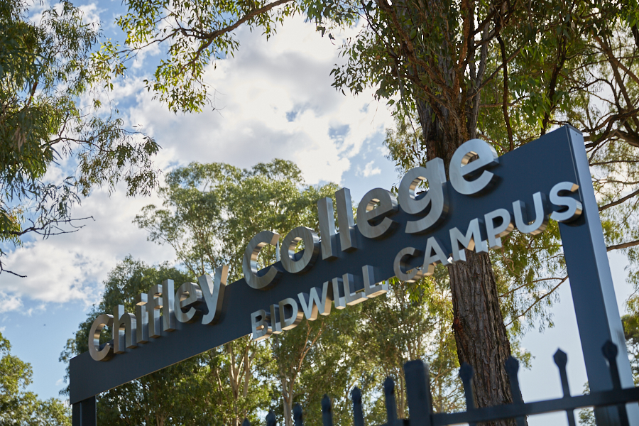

It is very exciting to be able to welcome everyone to 2021 at Bidwill Campus. It is wonderful to be back in these familiar surrounds after having a very interesting time at Kellyville High School last year. I would like to give a big thank you to Mr White for managing the job so well for a period of time that turned out to be a lot longer than expected.

The year has started off as close to ‘normal’ as we could hope for and we are planning for a year without interruptions or major distractions. One thing that is different is that we are now required to have all visitors check in with our unique QR code. It is a practice we have mostly become accustomed to but it is another ‘extra’ step. If you are just coming up to the office to buy uniform or make a brief inquiry you won’t be asked to sign in but if you are attending a function or a meeting you also need to go through the extra documentation steps.

One big thing we learned from last year was how damaging interruptions to learning can be for some students. With no problems like that on the horizon, it is worth emphasising how important regular attendance is at school and now is the time for us all to be helping students establish good patterns of turning up to school every day, ready to learn. This school is very fortunate to have been given some extra resources to make up for the problems from last year but students need to be at school to receive the benefits of all this.

Have a great week and best wishes for a terrific year,

Mr M. Burnard

Principal

UP-COMING EVENTS

This week
- Year 12 Clovelly excursion (rescheduled from last year) – Friday Feb 5

Next Week
- Year 10 and Year 12 Drama excursion to Belvoir Theatre – Fangirls – Wednesday Feb 10.

Further Ahead
- Year 12 Construction Work Placement – Monday March 8

