Bidwill Events

Term 2 Week 4: May 10 to 14

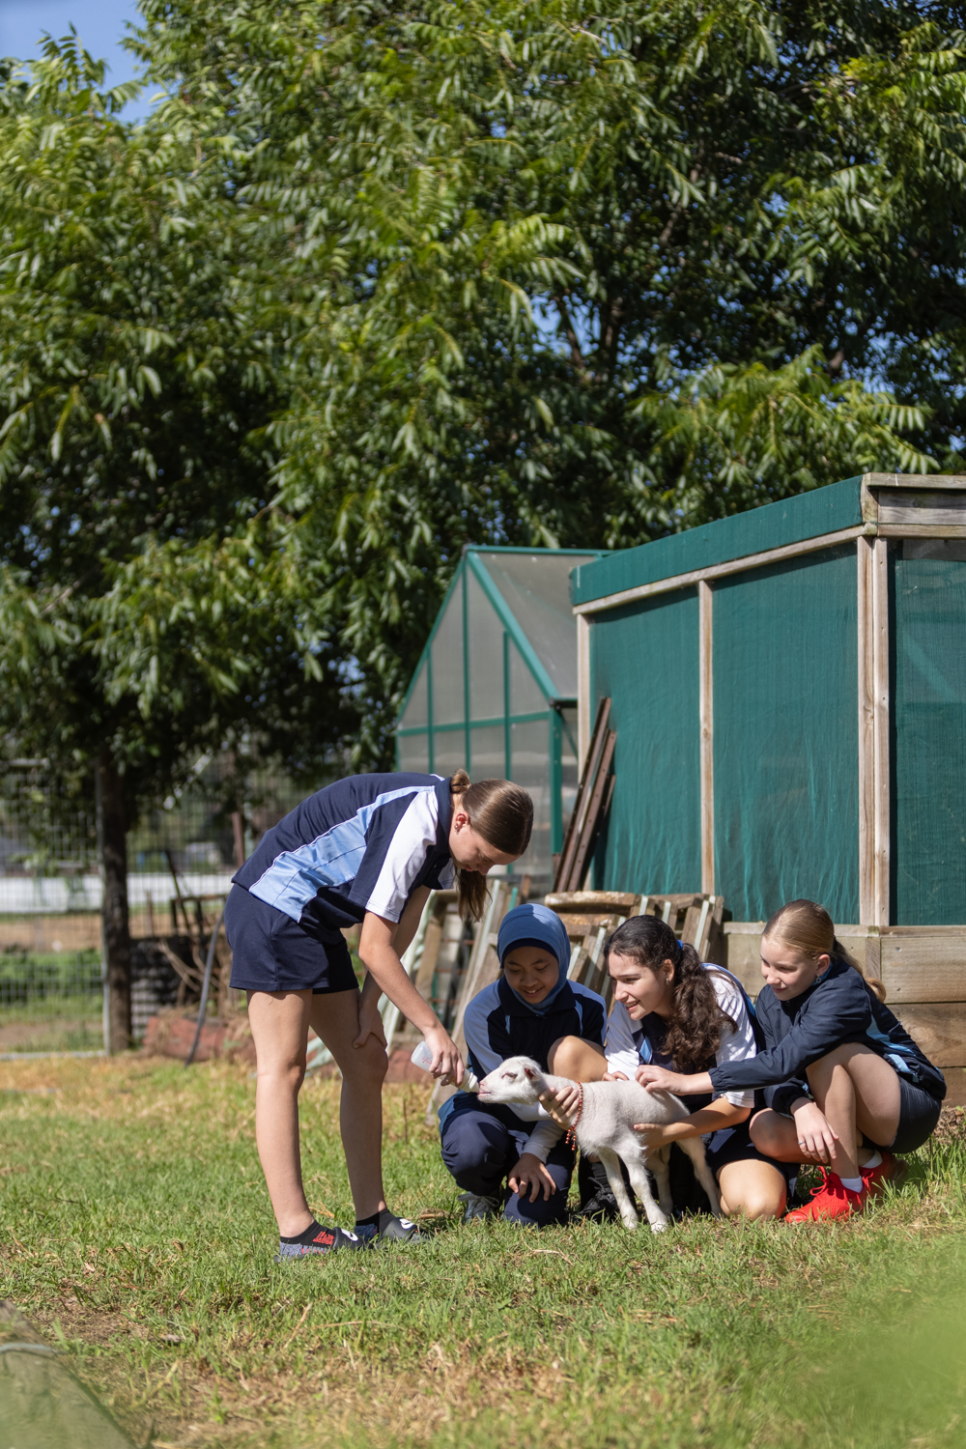

NAPLAN is on this week which is especially important for Years 7 and 9. Everyone can get a bit nervous about formal assessments like these but it is important for all students to just do their best. The results don’t go on reports and have no impact on students progressing to the next stage in their education. The information that comes back however, tells us a lot about how effectively we are working in helping students grow in their literacy and numeracy skills. They are also, of course, a good indicator to students and families of the same thing. NAPLAN is a big operation across the school that needs rooming and timing changes so it requires some cooperation from everyone in order for Year 7 and 9 students to be able to just do their best.

Have a great week,

Mr M. Burnard

Principal

UP-COMING EVENTS

This Week
- NAPLAN – all Year7 and all Year 9 – Tuesday May 11 to Thursday May 13
- Year 11 & 12 Legal Studies excursion – Friday May 14

Next Week
- Debating competition – Tuesday May 18
- Year 12 Biology excursion – Wednesday May 19

Further Ahead
- SRC Leadership Camp – Thursday/Friday May 27/28

